**DAILY ONLINE ACTIVITIES SUMMARY**

|  |  |  |  |  |  |  |  |  |
| --- | --- | --- | --- | --- | --- | --- | --- | --- |
| **Date:** | 27/05/2020 | | | | | **Name:** | D Richard Franklin | |
| **Sem & Sec** | Fourth SEM section A | | | | | **USN:** | 4AL18CS020 | |
| **Online Test Summary** | | | | | | | | |
| **Subject** | | Object Oriented Concepts | | | | | | |
| **Max. Marks** | | 30 | | **Score** | | | 29 | |
| **Certification Course Summary** | | | | | | | | |
| **Course** | [Certified Kubernetes Administrator (CKA) with Practice Tests](https://www.udemy.com/course/certified-kubernetes-administrator-with-practice-tests/) | | | | | | | |
| **Certificate Provider** | | | Udemy | | **Duration** | | | 3 Hour |
| **Coding Challenges** | | | | | | | | |
| **Problem Statement:** 1. Stack operation using SLL  2. Round robin type of process scheduling | | | | | | | | |
| **Status:** Completed | | | | | | | | |
| **Uploaded the report in Github** | | | | | YES | | | |
| **If yes Repository name** | | | | | <https://github.com/richard3658/lockdown-coding> | | | |
| **Uploaded the report in slack** | | | | | YES | | | |

**Online Test Details:**

The online test was from module 5 which was about the introduction to applets, swings and about different event handling topics in JAVA. There were 30 questions and the duration was 40 minutes. The questions were optimal and were easy. The score that I got in the test is 24/30.

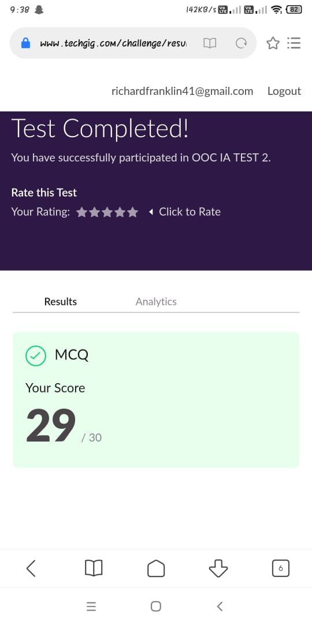

**Certification Course Details:**

**Name of the course**: [Certified Kubernetes Administrator (CKA) with Practice Tests](https://www.udemy.com/course/certified-kubernetes-administrator-with-practice-tests/)

**Certificate Provider**: Udemy

This course has 17 sections and the total duration is 15 hours.

In the ninth day I went through the section of the course that explained about scheduling and on how scheduling is done with all other key components explained. Had also done few tasks given by them.

**Snapshot:**

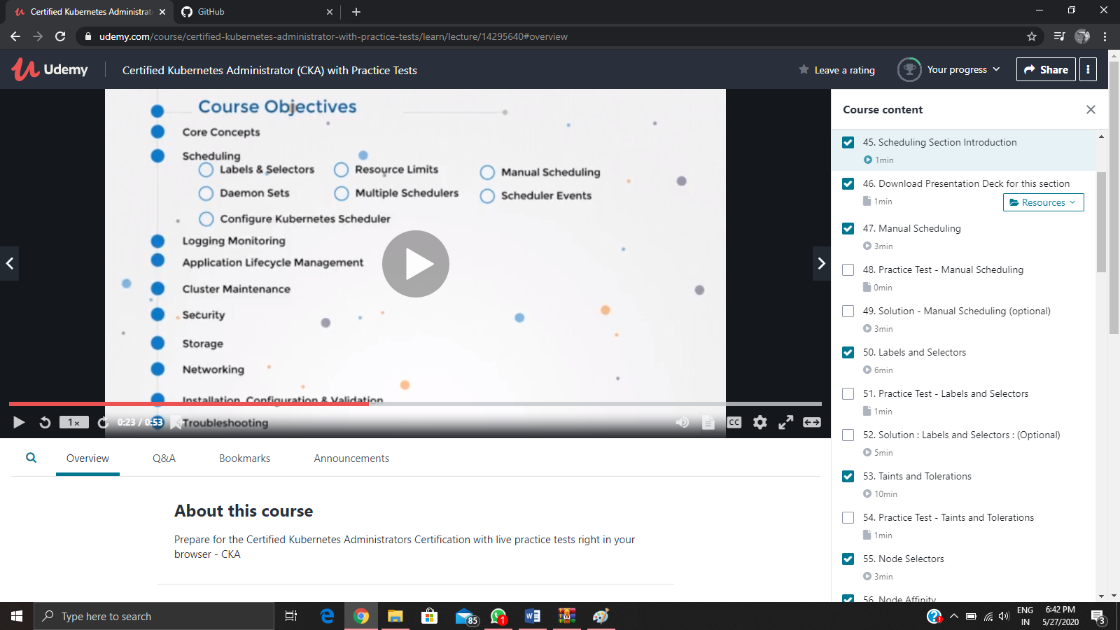

**Online Coding Details:**

Problem 1: (using C language) [In Bubble sort, each pass consists of comparison each element in the file with its successor (i.e. x[i] with x[i+1]) and interchanging two elements if they are not in the proper order. The array may be sorted in any pass. If the array is sorted, then remaining passes should be skipped off.Write a C Program to sort an array of integers in ascending order and display the sorted array and Number of passes performed for sorting.](https://github.com/orgs/alvas-education-foundation/teams/2nd-year/discussions/83)

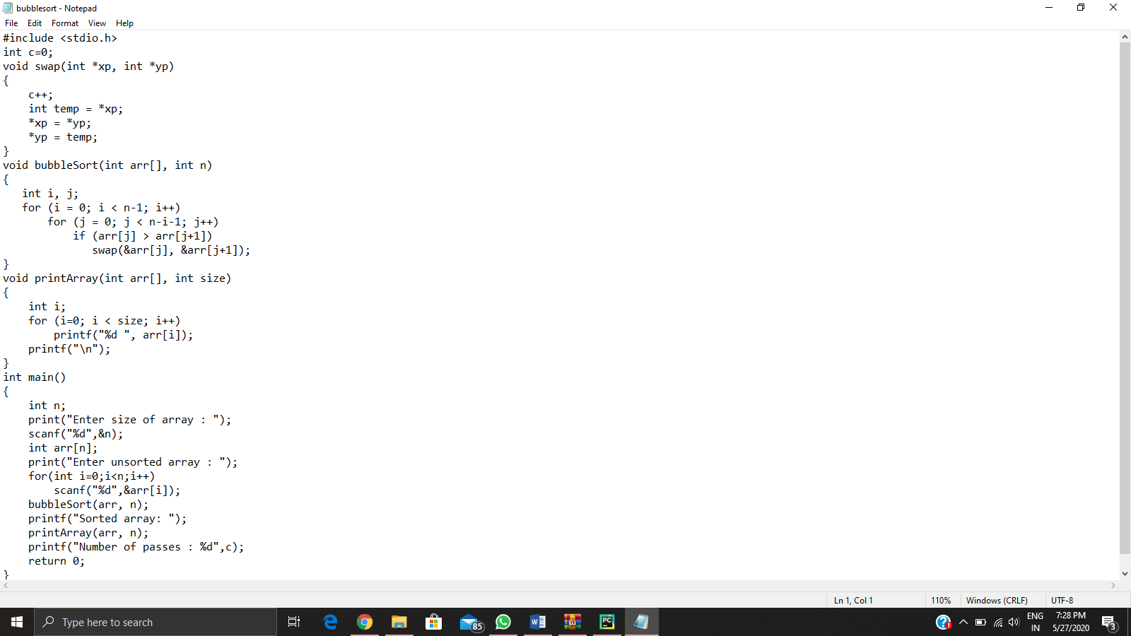

Problem 2: (Using python) [Given an array arr[] of the positive integers of size N, the task is to find the largest element on the left side of each index which is smaller than the element present at that index. Note: If no such element is found then print -1.](https://github.com/orgs/alvas-education-foundation/teams/2nd-year/discussions/82)

